USER MANUAL

Contents

Chapter 1 Introduction 2

1.1 About 2

1.2 About this Manual 2

1.3 Feedback 2

Chapter 2 Overview 2

Log In Screen 2

Register 3

Chapter 3 Usage 4

Manager 4

Maintainance Supervisor 5

Maintainance Officer 5

Store man 5

Secretary 6

# Chapter 1 Introduction

## About

This System Is a web based application meant to be used by the Estates Department to help simplify work issue, inventory management and expenditure usage.  
The System has been written in php.

## About this Manual

This manual covers most of the systems functionalities and possible errors encountered. Feel free to contact a computer expert if a problem not documented occurs.

## Feedback

If you have a question or feedback about the system feel free to contact us @ [johndevs@gmail.com](mailto:johndevs@gmail.com).

# Chapter 2 Overview

Users will first be greeted with the Home Screen. Register

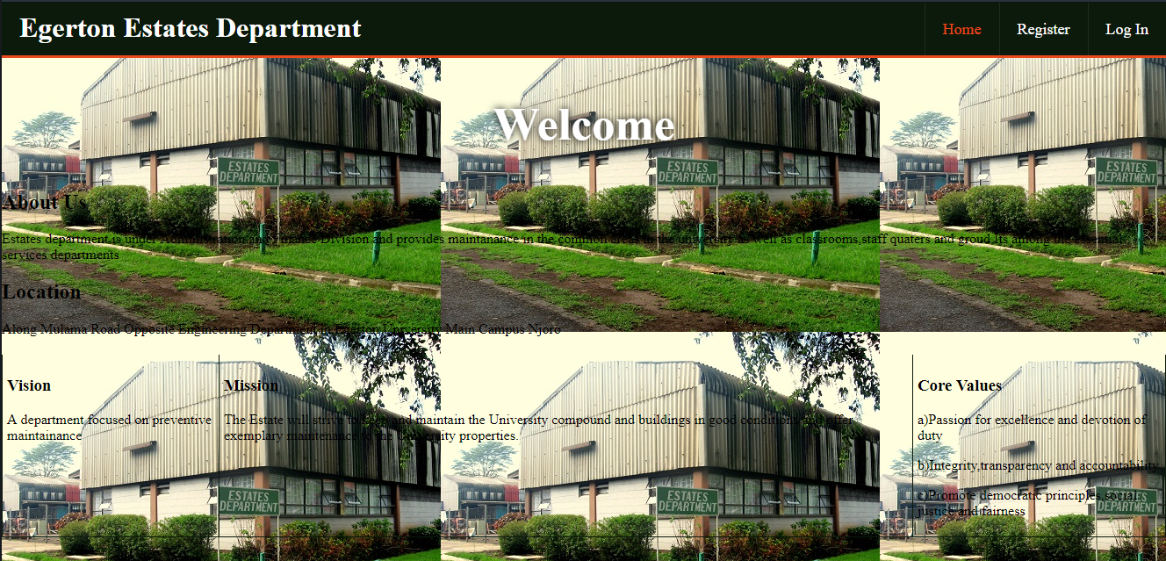

A new user or employee at that has to first register in order to use the system, but has to be approved by the manager before he/she can use the system

Log In Screen

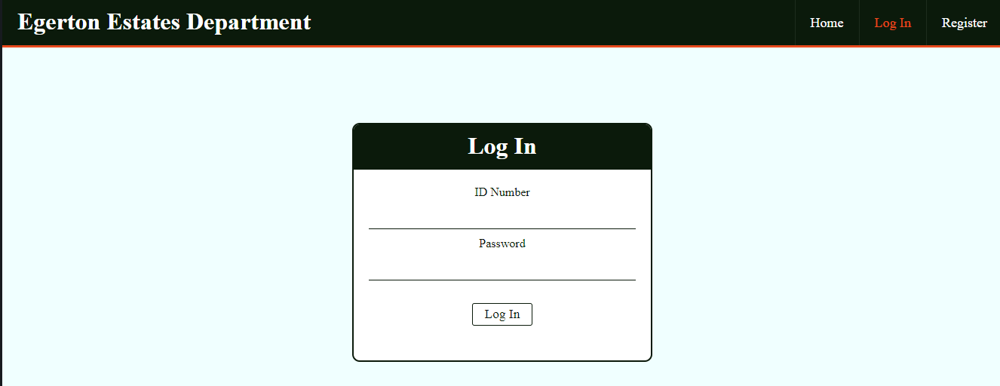

Already registered users can use the system by entering their credentials  
Entering of a wrong id or password will result in an error message being displayed

### Register

Register Screen

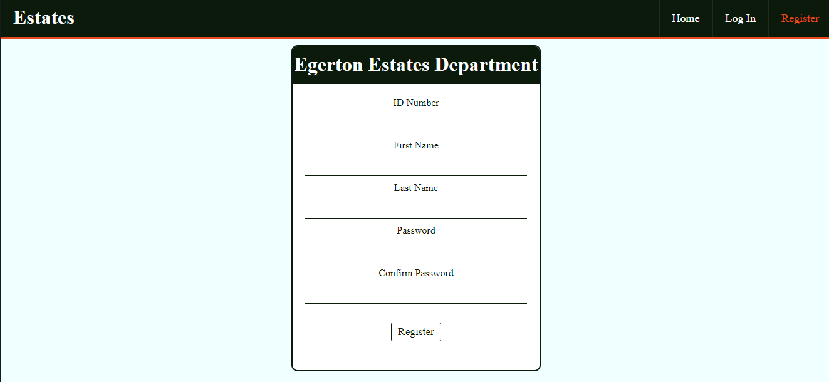

A user will enter his/her credentials after which he/she will be greeted with the following message

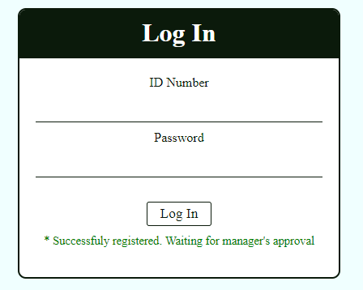

# Chapter 3 Usage

We have different ranks with manager being the highest to artisan being the lowest. We’ll start with the manager

### Manager

Upon logging in the manager will be greeted with the following screen

Work requests Screen

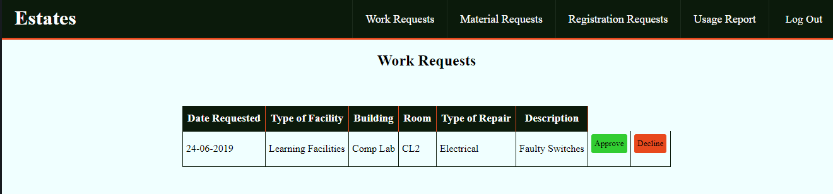

The manager can approve work requests as shown above, he/she can also approve registration requests for new employees

Registration request screen



The manager can also generate usage report on the expenditure usage for a certain period of time

### Maintainance Supervisor

The supervisor can only approve pending work requests



### Maintainance Officer

The Officer also approves pending work requests

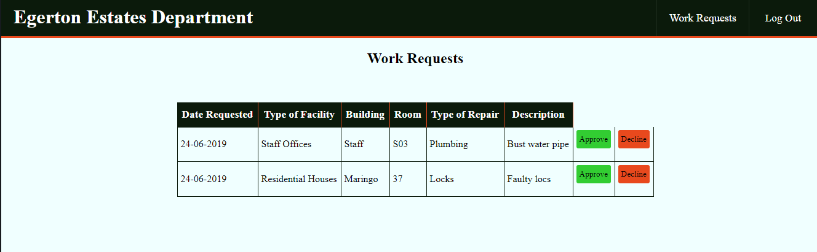

### Store man

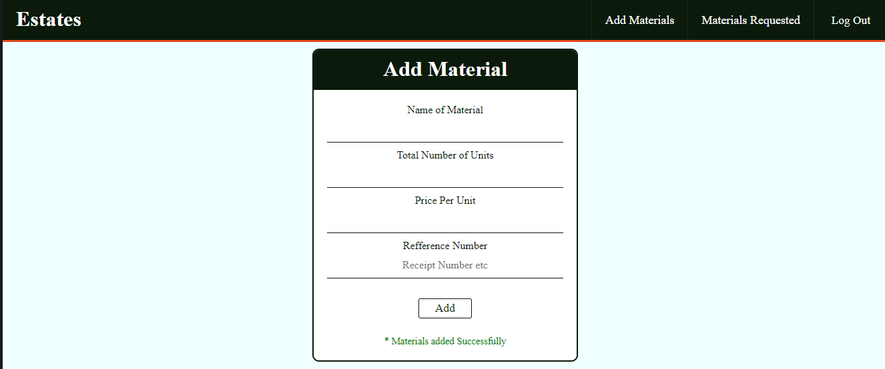

The store man can add materials in the store into the database as shown above ans can also approve or reject requested materials

### Secretary

The secretary submits work requests

